


AE 350
Final Project
December 13, 2006

Different Project than steve and poe’s 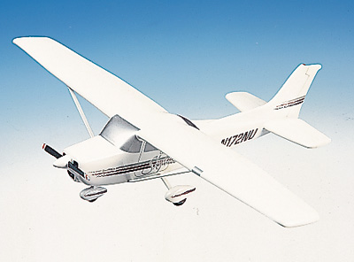

Table of Contents:

Introduction and General Information………………………….3

V-N Diagram……………………………………………………...4 - 5

Structural Design Loads…………………………………………6-9

Wing Torsion……………………………………………………..10

Wing Skin and Spar Web Thickness……………………………10 - 12

Wing Bending Flexure…………………………………………...12 - 13

Combined Flexure and Torsion…………………………………13 – 15

Closing…………………………………………………………….15

Appendixes……………………………………………………….16 - End

Introduction and General Information:

The Cessna 172 Skyhawk is an all-metal, high wing, single-engine airplane with a tricycle landing gear. The construction of the fuselage is a conventional formed sheet metal. The major structural areas are the front and rear carry-through spars to which the wings are attached, a bulkhead and forgings for main landing gear attachment, and a bulkhead with attaching plates at the base of the forward door posts. Four engine mount stringers are also attached to the forward door posts and extended forward to the firewall.
The wings are externally braced and contain the fuel tanks. The Cessna 172 Skyhawk has an upswept wing, an aspect ratio of 7.44, and airfoil-section thickness ratios that vary from 14 percent at the root to 12 percent at the tip. They are constructed of a front and rear spar with sheet metal ribs, doublers, and stringers. The entire structure is covered with an aluminum skin. Conventional hinged ailerons and single-slot flaps are attached to the trailing edge of the wings. The ailerons are constructed of a forward spar containing a balance weight, metal ribs, and aluminum skin joined together at the trailing edge.
The empennage consists of a conventional vertical stabilizer, rudder, horizontal stabilizer, and elevator. The vertical stabilizer consists of a spar, formed sheet metal ribs and reinforcements, a wrap-around skin panel, and formed leading edge skin. To improve directional stability, the vertical tail has a relatively large dorsal fin together with a small ventral fin. The rudder is constructed of a formed leading edge skin containing hinge halves, ribs, and a ground adjustable trim tab at the base of the trailing edge.

Engine:

The airplane is powered by a horizontally-opposed, four-cylinder, air-cooled engine. The engine is a Lycoming Model and is rated at 160 horsepower at 2700 RPM. The engine has a belt driven alternator and dual magnetos.

Performance:

- Max Speed at Sea Level 125 knots
- Max Cruise Speed 122 knots
- Max Range (40 Gallons) 575 NM (Approximately 5.7 hours)
- Service Ceiling 14,200 ft.
- Takeoff – Ground Roll 805 ft.
- Takeoff– distance to clear 50 ft. 1440 ft.

Weights and Loading:

The Skyhawk is a recreational aircraft designed for stable flight and moderate maneuvers. Although the standard empty aircraft weighs under a ton the Skyhawk can hold loads exceeding half its weight.

- Max Weight 2300 lbs
- Standard Empty Weight 1393 lbs
- Max Useful Load 907 lbs
- Baggage Allowance 120 lbs
- Wing Loading 13.2 lb/ft²
- Power Loading 14.4 lb/HP
- Fuel Capacity 43 gallons

Dimensions:

The Cessna 172 seats a maximum of two occupants. This model arranges both occupants side by side. The aircraft’s wingspan is slightly longer than its overall length which increases the wind area for needed lift. The Cessna 172 utilizes a two fin propeller.

- Airfoil Thickness 6.4 inches (mid wing)
- Wing Span 36 ft
- Wing Area 174 ft²
- Height Overall 9.8 ft
- Length Overall 26.9 ft
- Tail Span 11.33 ft
- Propeller: fixed pitch (diameter) 75 in
- Cabin
  - Length 7.5 ft
  - Height 4 ft
  - Width 5 ft

Speeds for Normal Operation:

Based on the aircrafts light weight, its takeoff and landing speeds are relatively low. The Cessna can adjust its speeds accordingly to complete normal and sometimes short field takeoffs.

- Normal Climb out of Takeoff 70-80 KIAS
- Short Field Takeoff 59 KIAS
- Best Rate of Climb (Sea Level) 73 KIAS
- Best Rate of Climb (10,000 ft) 68 KIAS
- Normal Landing Approach 60 KIAS
- Balked Landing (Flaps 20°) 55 KIAS
- Max Crosswind Velocity 15 knots

V-N Diagram

The purpose V-N diagram is used to represent the loading and structural limits that a certain aircraft can withstand until failure. The diagram plots maximum positive and negative load factors which are signified by the horizontal lines. The chart helps to capture at a glance the positive and negative stall limits as they are functions of velocity.

Equations used to calculate the core points on the diagram:

n_{max} = C_{Lmax}*q*S

q = ½*ρ_{sL}*V_{e}²

V_{stall} = sqrt[(2*n*W) / (ρ_{sL}*S*C_{Lmax})]

Specified Cessna Data:

Gross Area, S = 174 ft²
Aspect Ratio, AR = b²/S = 7.44
Taper Ratio, λ = .687
TOGW = 2300 lb
Empty Weight = 1393 lb
n_{max} = 3.1
n_{min} = -1.25

Figure 1
Altitude: Sea Level
Weight: 2300 lbs
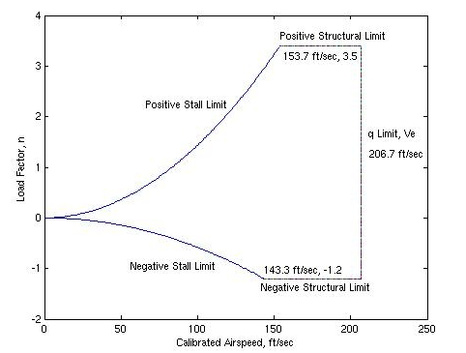

Structural Design Loads

Computing shear force and bending moment for the Skyhawk provides a detailed model of the stresses acting on the each wing. These forces are created from total lift force and the wing and fuel weight. To accurately represent the shape of the wing it is separated into ten sections as seen in Figure 2. Each section has both an elliptical and trapezoidal chord length. The average chord length and area of each section is then used to calculate the Shear Force and Bending Moment on each section of the wing. Total Force is computed from the difference between each sections lift force subtracted by the total weight force. Bending Moment is computed using the Total Force on the wing section.

Figure 2
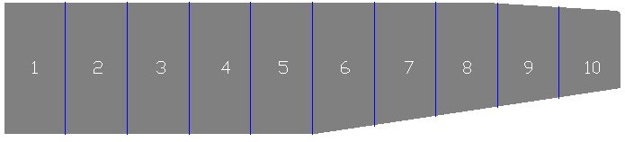
Calculating total lift for each wing:

Total Lift = n_{max}*TOGW*FS / 2

Total Lift = 5347.5 lbs

The average chord distance for each section:

C_{avg} = C_{trapezoidal} + C_{elliptical} / 2 (Eqn. 1.1)

C_{trapezoidal} = C_{r} [1-2/y * (1-λ)] (Eqn. 1.2)

C_{elliptical} = (4S / Πb) * sqrt[1- (2y/b)²] (Eqn. 1.3)

C_{avg} is found along with the area of each section. After, solving for f, the force coefficient, the lift force on each strip is established.

Each separate force; lift, fuel, and wing weight have different coefficients. They are:

f_{lift} = LIFT / Wing Area (half) (Eqn. 2.1)

f_{fuel} = Fuel weight / Wing Area (half) (Eqn. 2.2)

f_{wing} = Wing weight / Wing Area (half) (Eqn. 2.3)

- Note: Wing weight = 7.5% of empty weight.
Density of gasoline = 803 kg/m³

Lift force on each strip:

L_{force} = A_{strip} * f (Eqn. 2.4)

Total force on each strip:

Total Force = L_{force} – [ f_{fuel}*Area - f_{wing}*Area] (Eqn. 3.1)

Shear Force on each strip:

Σ_{i} Total Force_{i} (Eqn. 4.1)

Using the total force the Bending Moment is worked out:

BM = Σ_{i} Total Force_{i}* y distance (from fuselage) (Eqn. 5.1)

Table 1
C(y)elip [ft] | y distance [ft] | C(y)trap [ft] | C(y) avg [ft] | Area of Section [ft²]
6.150 | 0.000 | 5.330 | 5.740 | 10.242
6.120 | 1.800 | 5.160 | 5.640 | 9.984
5.910 | 3.600 | 4.996 | 5.453 | 9.723
5.870 | 5.400 | 4.830 | 5.350 | 9.450
5.640 | 7.200 | 4.660 | 5.150 | 9.059
5.330 | 9.000 | 4.500 | 4.915 | 8.586
4.920 | 10.800 | 4.330 | 4.625 | 8.010
4.390 | 12.600 | 4.160 | 4.275 | 7.306
3.690 | 14.400 | 3.995 | 3.843 | 6.388
2.680 | 16.200 | 3.830 | 3.255 | 4.577
0.000 | 18.000 | 3.660 | 1.830 | 0.000
 |  |  | Total Area: | 83.323

- Table 1 represents the calculations necessary to solve for average chord length for each section (refer to the equations 1.1-1.3). An average is taken between the elliptical and trapezoidal chord lengths. The area of each section is then computed. Checking the calculated values with Figure 2 proves the accuracy of the values.

Table 2
Force of Lift [lb] | Force of Fuel Weight [lb] | Force of Wing Weight [lb] |  | Total Force [lb]
690.444 | 16.797 | 12.301 |  |  | 661.346
673.031 | 16.373 | 11.990 |  |  | 644.667
655.436 | 15.945 | 11.677 |  |  | 627.814
637.053 | 15.498 | 11.349 |  |  | 610.205
610.661 | 14.856 | 10.879 |  |  | 584.925
578.808 | 14.081 | 10.312 |  |  | 554.415
539.978 | 13.136 | 9.620 |  |  | 517.222
492.503 | 11.981 | 8.774 |  |  | 471.747
430.617 | 10.476 | 7.672 |  |  | 412.470
308.516 | 7.505 | 5.496 |  |  | 295.514
0.000 | 0.000 | 0.000 |  |  | 0.000

- Table 2 characterizes all of the forces which act on each section. The equations above were used along side of the computed force coefficients (Equations 2.1-2.3) to solve for lift, weight, and wing weight forces. Equation 3.1 was used to calculate Total Force.

Table 3
Shear Force [lb] | Bending Moment [lb.ft]
4718.980 | 38173.735
4074.312 | 37013.334
3446.498 | 34753.202
2836.293 | 31458.093
2251.367 | 27246.630
1696.952 | 22256.893
1179.730 | 16670.899
707.984 | 10726.888
295.514 | 4787.323
0.000 | 0.000
0.000 | 0.000

- Table 3 corresponds to the Shear and Bending Moments for each section of the wing. These equations can be found from above, Equations 4.1 & 5.1.

Figure 3
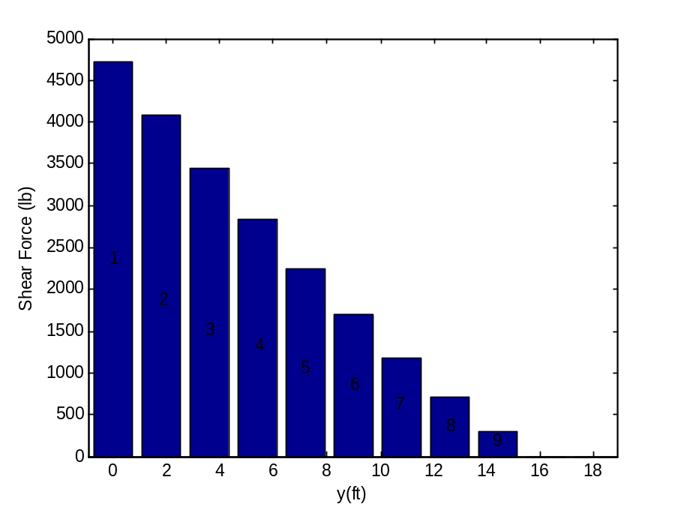
- Figure 3 represents the Shear Force versus the distance away from the fuselage. The Shear Force is the summation of Total Forces outboard of that section. The sections are labeled accordingly on the graph.

Figure 4
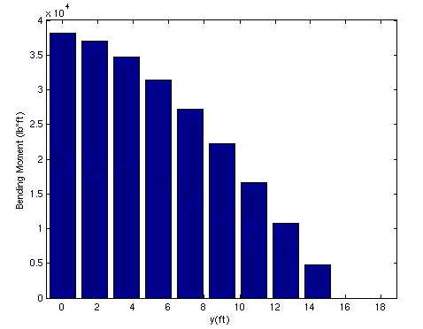
- Figure 4 represents the Bending Moment as the distance away from the fuselage increases. As with the Shear Force, Bending Moment is the summation of the bending moment’s outboard of that specific section.
Wing Torsion

Wing torsion is an important aspect of aircraft performance and stability. Minimizing wing torsion will improve these features of flight.

T_{s} = C_{m} * q_{max} * (Strip Area)(Strip Chord) (Eqn. 6.1)

As the formula suggests the Torsion value will change as distance from the fuselage increases. This occurs due to the shape of wing and changing chord length.

C_{m} = -0.1
q_{max} = 50.8 lb/ft²

Table 4
 | Root | Midspan | Tip
Torsion [lb.ft]: | -298.65 | -214.38 | -75.67

- Table 4 represents the Torsional at three points along the wing using equation 6.1. The values decrease which is anticipated from the formula. The tip was assumed to be the last section of the wing (section 10).

Table 5
Torsion [lb.ft] | Torsional Moment [lb.ft]
-298.65 | -1810.79
-286.04 | -1524.74
-269.33 | -1255.41
-256.83 | -998.58
-236.99 | -761.59
-214.38 | -547.22
-188.19 | -359.02
-158.66 | -200.36
-124.69 | -75.67
-75.67 | 0.00
0.00 | 0.00

- Table 5 symbolizes the Torsional Moments along the wing. The moments at each section were computed by summing the torsions outboard of that section.

Wing Skin and Spar Web Thickness:

Solving for skin and spar web thickness requires the dimensions of the wing airfoil at root, mid-span, and tip. These airfoils will describe the areas of the wing cross section at each segment of the wing. Correctly assuming the wing airfoil decreases along with chord length then the area should as well. Based on the fact skin and spar web thickness is directly related to the cross sectional wing area and Torque solved for above, the thicknesses will decrease as predicted.
Figure 5
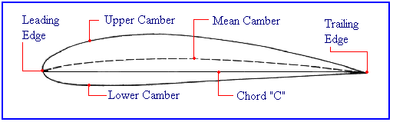
- Figure 5 embodies what a general wing cross section looks like. The airfoil height will decrease as distance from the fuselage increases.

Equations:

T = 2Aq Eqn. 6.1

q = τ * t Eqn. 6.2

Figure 6
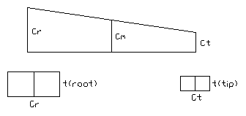
- Figure 6 represents the general diagram used to visualize the cross sections at root and tip. The same procedure was used for the mid-span section but was not included in the diagram.

σ_{Y} = 47,000 psi
t_{root} = 7.47 in
t_{mid} = 6.4 in
t_{tip} = 2.38 in

Solving for Area at each section of the wing:

A = C*t

A_{root} = 3.57 ft² A_{mid} = 2.57 ft² A_{tip} = .363 ft²

Solving q at each section of the wing using equation 6.1:

q_{root} = 253.39 lb/ft

q_{mid} = 104.39 lb/ft

q_{tip} = 104.25 lb/ft

Using the torsional moment (Torque) solved above and the value of q, the thickness to prevent yielding can be computed using equation 6.2.

Wall thickness_{(root)} = .0089 in

Wall thickness_{(mid-span)} = .0037 in

Wall thickness_{(tip)} = .0036 in

Wing Bending (flexure):

To approximate the wing sections at root and mid-span the cross section is represented by a symmetric rectangle where A signifies the concentrated area at each spar cap. These concentrated areas are required to be a certain size which will prevent yielding.

Figure 7

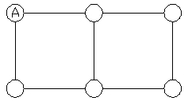
- Figure 7 shows the cross section of the wing. At root and mid-span the concentrated area, A, along with the airfoil thickness or height t will change based on wing geometry.

Solving I_{y} in terms of A gives the following equation:

I_{y} = 6A(t/2)²

To solve for A such that there is no yielding:

σ_{xx} = σ_{Y} = 47,000 psi σ_{xx} = M_{y} z / I_{y} Eqn. 6.3

Using equation 6.3 and the previously solved bending moment from step 2:

t_{root} = 7.47 in z_{root} = t/2 = 3.735 in
t_{mid} = 6.4 in z_{mid} = 3.2 in
t_{tip} = 2.38 in

Therefore to prevent yielding:

A_{root} ≤ 0.0362 in² A_{mid} ≤ 0.0302 in²

The value for Area from root to mid-span decreases as predicted.

To compute bending stress the known concentrated areas are used and substituted in to equation 6.3:

I_{y(root)} = 3.034 in⁴ I_{y(mid)} = 1.843 in⁴
σ_{xx(root)} = 46,990.7 psi σ_{xx(mid)} = 46, 993.1 psi

Combined Flexure and Torsion:

To calculate the shear stress on the wing sections at root and mid-span the Shear Force and Torsional Moment are added to the wing cross section diagram. The combined Flexure and Torsion produce a certain shear flow in both segments of the cross section which are labeled 1 and 2. Computing the shear flow in each segment leads to finding the shear stress. The thickness t is assumed constant throughout the cross section. Figure 8 below is used as a visual aid in solving the shear flow at the root and mid-span. The shear force, V_{z}, is assumed to act at c/4 as the Torsional Moment < 1.

Figure 8
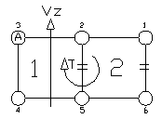
- Figure 8 is the diagram used at the wind root and mid-span. The skin and spar thickness t, the airfoil thickness and the width of the wing segment decrease from root to tip.
Define the constants:

Torsional Moment_{root} = -1810.79 lb.ft
Torsional Moment_{mid} = -761.59 lb.ft

V_{z(root)} = 4718.98 lb
V_{z(mid)} = 2251.37 lb

Area of spar caps is defined as A.

Wall thickness_{(root)} = .0089 in
Wall thickness_{(mid-span)} = .0037 in

Equations used to solve for shear flow and shear stress:

q’_{xy} = -V_{z}*Q_{xy} / I_{y} Eqn. 7.1

q = τ * t Eqn. 7.2

To prevent yielding: τ = 0.5 σ_{Y} σ_{Y} = 47,000 psi

Solving for shear flow is documented in the appendixes. Using equations 7.1 and 7.2 the results are as follows:

Shear Flow and Shear Force at ROOT:
q₁ = 426.37 lb/in τ₁ = 47906.74 lb/in

q₂ = 215.78 lb/in τ₂ = 24244.9 lb/in

Shear Flow and Shear Force at MID-SPAN:
q₁ = 325.6 lb/in τ₁ = 88000.0 lb/in

q₂ = 31.5 lb/in τ₂ = 8513.5 lb/in

Using the known Shear Stress the spar cap area and web/skin thickness can be deliberated. These values are calculated to prevent yielding.

Using equation 7.2 and τ = .5 σ_{Y} solve for the skin/web thickness can now be found. Two values for thickness are found from the different shear forces but the larger value must be taken to make sure there is no yielding. The Area is also documented:

t_{root} = 0.018 in t_{mid} = 0.014 in
A_{root} = 0.0362 in² A_{mid} = 0.0302 in²

Calculating the twist angle:

Equations:

Θ = 1/ 2A_{1(bar)}* ∫_{o} q/t dS Eqn. 8.1

α = θ*l Eqn. 8.2

Calculations to solve the total twist angle can be found in the appendixes. Equations 8.1 and 8.2 were used chronologically.

Define constants:

A_{bar(root)} = 256.97 in² A_{bar(mid)} = 188.7 in²
l_{root} = 68.8 in l_{mid} = 58.98 in

G = 3.95 x 10⁶ psi

Solving for twist angle:

α_{root} = 0.000742 rad.in

α_{mid} = 0.021 rad.in

As distance from the fuselage increases the twist angle also increases as expected.

Closing:
Throughout the technical report sanity checks were made to verify the accuracy of each calculated value. The equations used were supported by the Mechanics of Aircraft Structures written by C.T. Sun. All diagrams were created in AutoCAD 2006 and graphs were plotted in MATLAB 7.0. The MATLAB code utilized in the report is cited in the appendixes as well.

Reference:
- Ratan Jha
- http://www.allstar.fiu.edu/AERO/flight31.htm [Figure 5]

APPENDIXES

MATLAB program used for V-N diagram and shear force and bending moment graphs:

% Define the Variables %
S=174; %ft^2%
AR=7.44;
l=.687;
nmax=3.4;
nmin=-1.2;
CLpos=1.6;
CLneg=-.65;
p=.002377; %slugs/ft^3%
W=2300; %slug*ft/s^2%

% Define Equations %
V1=((nmax*2*W)/(CLpos*p*S))^(1/2)
V2=((nmin*2*W)/(CLneg*p*S))^(1/2)
Vpos=[0:V1];
Vneg=[0:V2];
q=50.8;
n1=(CLpos*p*S*Vpos.^2)/(2*W);
n2=(CLneg*p*S*Vneg.^2)/(2*W);
Vmax=((2*q)/p)^(1/2)

% Plotting Vn diagram %
plot(Vpos, n1)
hold on
plot(Vneg, n2)
hold on
plot([V1:.5:Vmax],nmax)
hold on
plot([V2:.5:Vmax],nmin)
hold on
plot(Vmax,[nmin:.01:nmax])

% Labeling Vn Diagram %
gtext ('Positive Stall Limit')
gtext ('Negative Stall Limit')
gtext ('Positive Structural Limit')
gtext ('Negative Structural Limit')
xlabel ('Calibrated Airspeed, ft/sec')
ylabel ('Load Factor, n')

